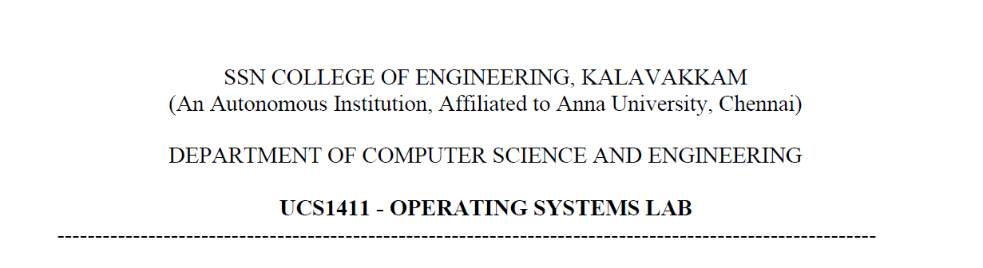

**NETWORKS LAB**

**EXERCISE 9**

Name: Jayannthan P T

Dept: CSE ‘A’

Roll No.: 205001049

Simulation of congestion control algorithms

**Aim:**

Write tcl script to simulate the different congestion control algorithms.

**Code:**

**Congestion control using TCP Tahoe**

set ns [new Simulator]

$ns color 1 Blue

$ns color 2 Red

set nf [open out.nam w]

$ns namtrace-all $nf

proc finish {} {

    global ns nf

    $ns flush-trace

    close $nf

    exec nam out.nam &

    exit 0

}

set n0 [$ns node]

set n1 [$ns node]

set n2 [$ns node]

$ns duplex-link $n0 $n1 10Mb 10ms DropTail

$ns duplex-link $n1 $n2 2Mb 10ms DropTail

$ns queue-limit $n0 $n1 10

$ns duplex-link-op $n0 $n1 orient right

$ns duplex-link-op $n1 $n2 orient right

set tcp [new Agent/TCP]

$tcp set class_ 2

$ns attach-agent $n0 $tcp

set sink [new Agent/TCPSink]

$ns attach-agent $n2 $sink

$ns connect $tcp $sink

$tcp set packetSize_ 1000

$tcp set window_ 65000

$tcp set fid_ 1

set cbr [new Application/Traffic/CBR]

$cbr set packetSize_ 500

$cbr set interval_ 0.001

$cbr attach-agent $tcp

$ns at 0.1 "$cbr start"

$ns at 4.5 "$cbr stop"

$ns at 4.5 "$ns detach-agent $n0 $tcp ; $ns detach-agent $n2 $sink"

$ns at 5.0 "finish"

$ns run

**Output:**

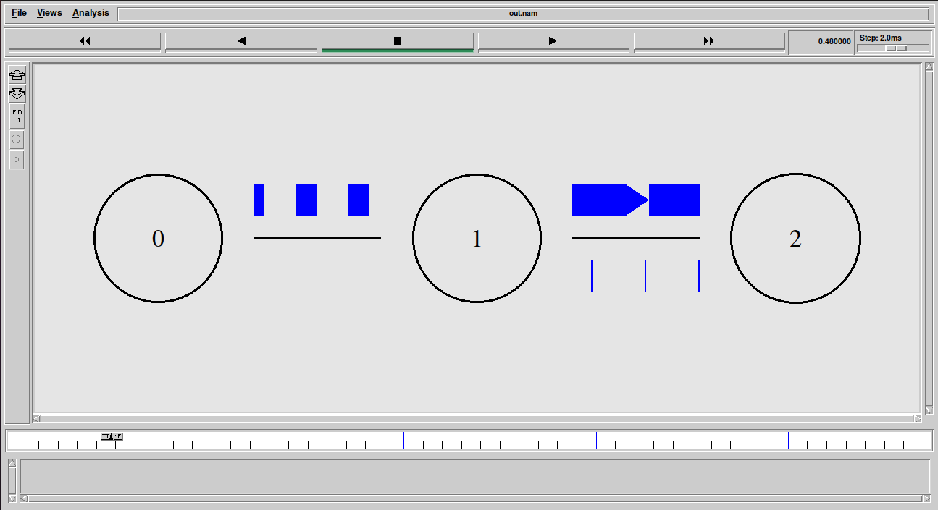

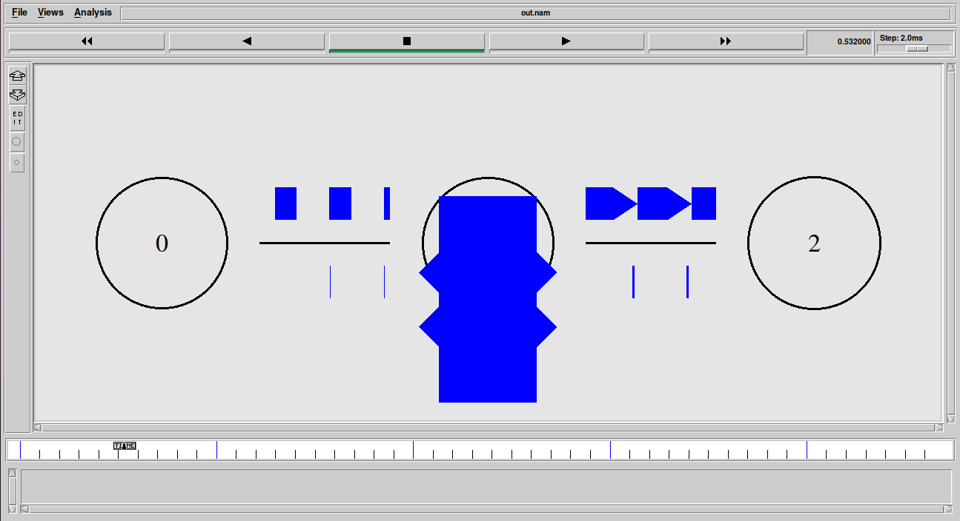

**Code:**

**Congestion control using TCP Reno**

set ns [new Simulator]

$ns color 1 Blue

$ns color 2 Red

set nf [open out.nam w]

$ns namtrace-all $nf

proc finish {} {

    global ns nf

    $ns flush-trace

    close $nf

    exec nam out.nam &

    exit 0

}

set n0 [$ns node]

set n1 [$ns node]

set n2 [$ns node]

$ns duplex-link $n0 $n1 10Mb 10ms DropTail

$ns duplex-link $n1 $n2 2Mb 10ms DropTail

$ns queue-limit $n0 $n1 10

$ns duplex-link-op $n0 $n1 orient right

$ns duplex-link-op $n1 $n2 orient right

set tcp [new Agent/TCP/Reno]

$tcp set class_ 2

$ns attach-agent $n0 $tcp

set sink [new Agent/TCPSink]

$ns attach-agent $n2 $sink

$ns connect $tcp $sink

$tcp set packetSize_ 1000

$tcp set window_ 65000

$tcp set fid_ 1

set cbr [new Application/Traffic/CBR]

$cbr set packetSize_ 500

$cbr set interval_ 0.001

$cbr attach-agent $tcp

$ns at 0.1 "$cbr start"

$ns at 4.5 "$cbr stop"

$ns at 4.5 "$ns detach-agent $n0 $tcp ; $ns detach-agent $n2 $sink"

$ns at 5.0 "finish"

$ns run

**Output:**

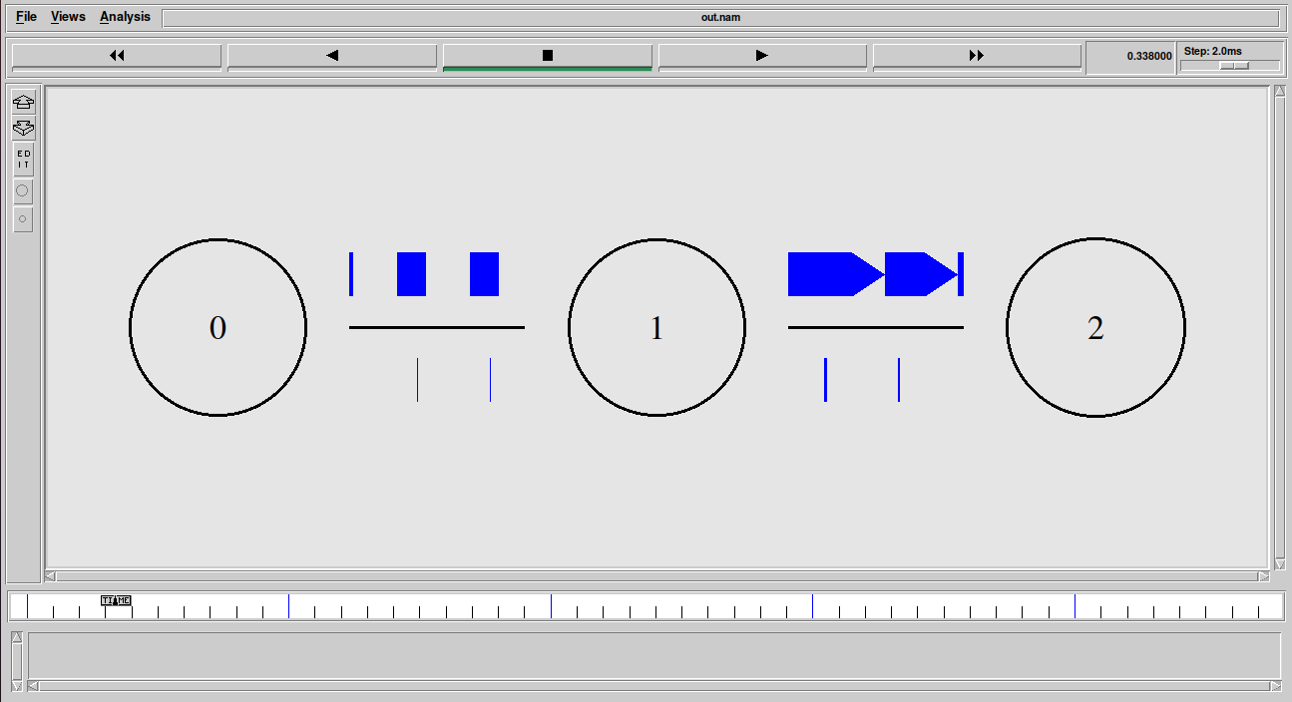

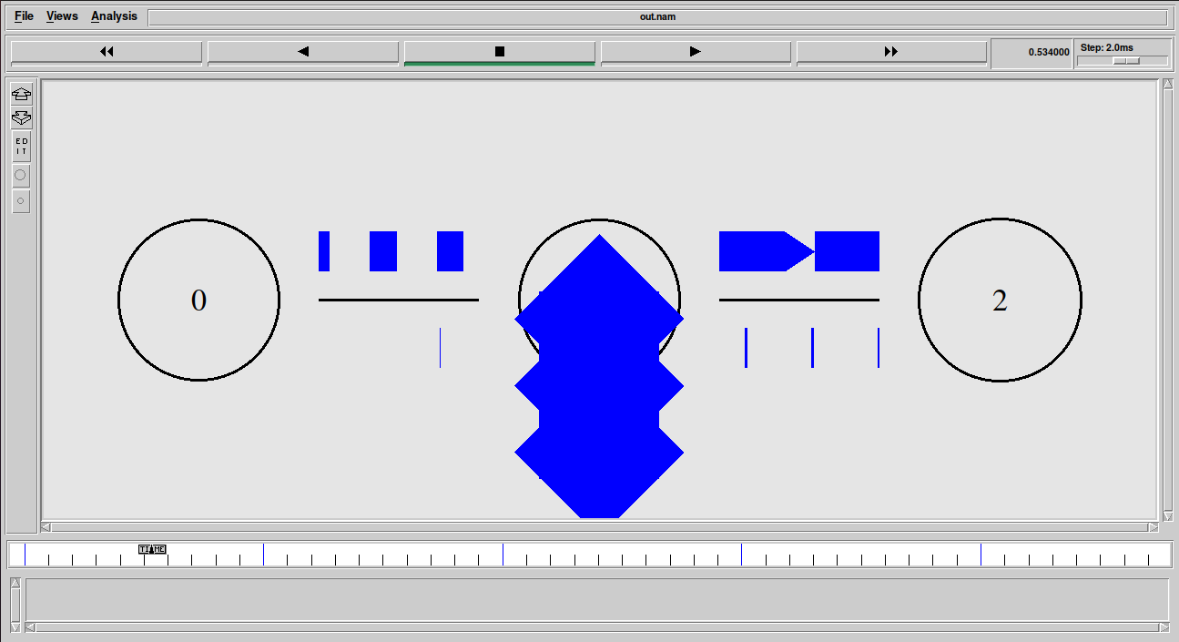

**Learning outcome:**

Learnt to implement simulate the different congestion control algorithms